**Simple Program in Dictionary**

**1. Write a simple program to store and display the value from the dictionary (use dictionary name in print)**

d={1:1,2:2,3:3,4:4,5:5,6:6,7:"ANAND"}

print(d)

**output:**



**2. Write a simple program to store and display the value from the dictionary (use loop to display each value from the dictionary).**

d={1:1,2:2,3:3,4:4;5:5}

for i in d:

print(d)

**output:**

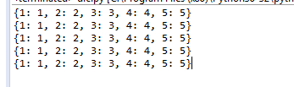

**3. Write a simple program to store and display the value from the dictionary by updating the single value in the dictionary.**

d1={1:1,2:2,3:3}

d2={4:4,5:5,6:6}

print(d1)

print(d2)

d1.update(d2)

print(d1)

**output:**

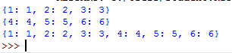

4. Write a simple program to store and display the value from the dictionary by deleting single value from the dictionary.

d1={1:1,2:2,3:3}

del(d1[2])

print(d1)

**output:**



**5. Write a simple program to store and display the value from the dictionary by deleting all values from the dictionary.**

d={1:1,2:2,3:3}

print(d.clear())

**output:**

